**The Black Consciousness movement**

in the 1970s

by the mid-1960s, major anti-apartheid organizations in South Africa such as the African National Congress and Pan-Africanist Congress

both silenced by government repression

a social, cultural, and political awakening in the country

redefined “black” as an inclusive, positive identity

idea: black South Africans could make meaningful change in their society if they were proud of themselves

awakening of their self-worth (international Slogan: ”Black is beautiful”) 

stresses the need for activism

in 1969, Steve Biko and other black students frustrated with white leadership in multi-racial student organizations formed an exclusively black association

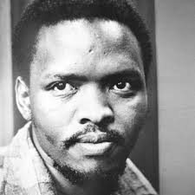development of:

* Black Theology
* cultural movements

led to the formation of new community and political organizations

Steve Biko: was one of the movement’s charismatic, leader and writer

the South African government understood the threat Black Consciousness posed to apartheid

Biko was banished to his home district

In 1977 he died at the hands of security police

This revealed the brutality of South African security forces

After Biko’s death, the state declared Black Consciousness–related organizations illegal.

Biko became a powerful icon of the Black Consciousness movement and was a celebrated hero

Peter Gabriel: Song for Steve Biko

<https://www.youtube.com/watch?v=luVpsM3YAgw>