**„Lord of the flies“**

**(Handout to the presentation by Svenja Golnik, Q4)**

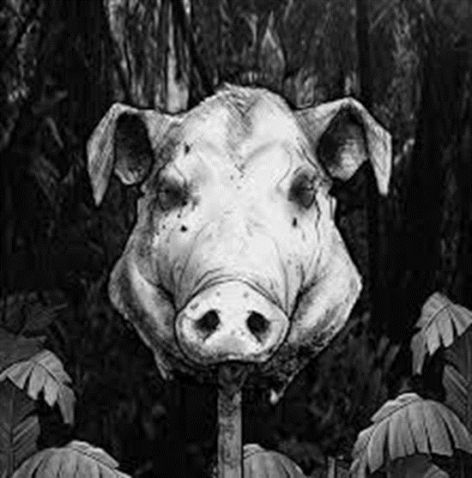**Information about „Lord of the flies“**

* author: William Golding
* publication date: 17th September 1954
* novel
* original language: English
* number of pages: 224
* day of the filming: 16th March 1990
* screenwriter: Jay Presson Allen

**Plot**

* group of boys -> outcast in the wild after plane accident
* afraid of the beast
* protagonist: Ralph (leader of the one group)
* antagonist: Jack (wannabe-leader)
* groups seperate -> hatred between both groups
* pig head “talks“ to Simon (group member): “Fancy thinking the Beast was something you could hunt and kill!... You knew, didn‘t you?“
* become rescued by a captain of a ship



**A little excursion to Dystopia**

* opposite of Utopia (Anti-Utopia)
* society developed to the negative
* often totalitarian system

**Why is the story dystopian?**

* chance for a new, better world/society
* instead of living in peace together -> war (different views)
* totalitarian system? (both groups -> leaders)
* really messed up society results (for example: sacrifice)

**Could the story become reality?**

|  |  |
| --- | --- |
| Pro | Contra |
| plane accidents can happen | **survival after plane accident improbable** |
| need for a leader | **knowledge about consequences (enlightenment)** |
| hope for a new beginning (new society) | **humanity is civilized** |
| different views in societies | **urge for peace in almost every person** |
| violence as a solution | **children aren’t that brutal** |

