**American Dream** 17:35 – 18:05 Q4a Manera/Kasikcier **Manera positive side**

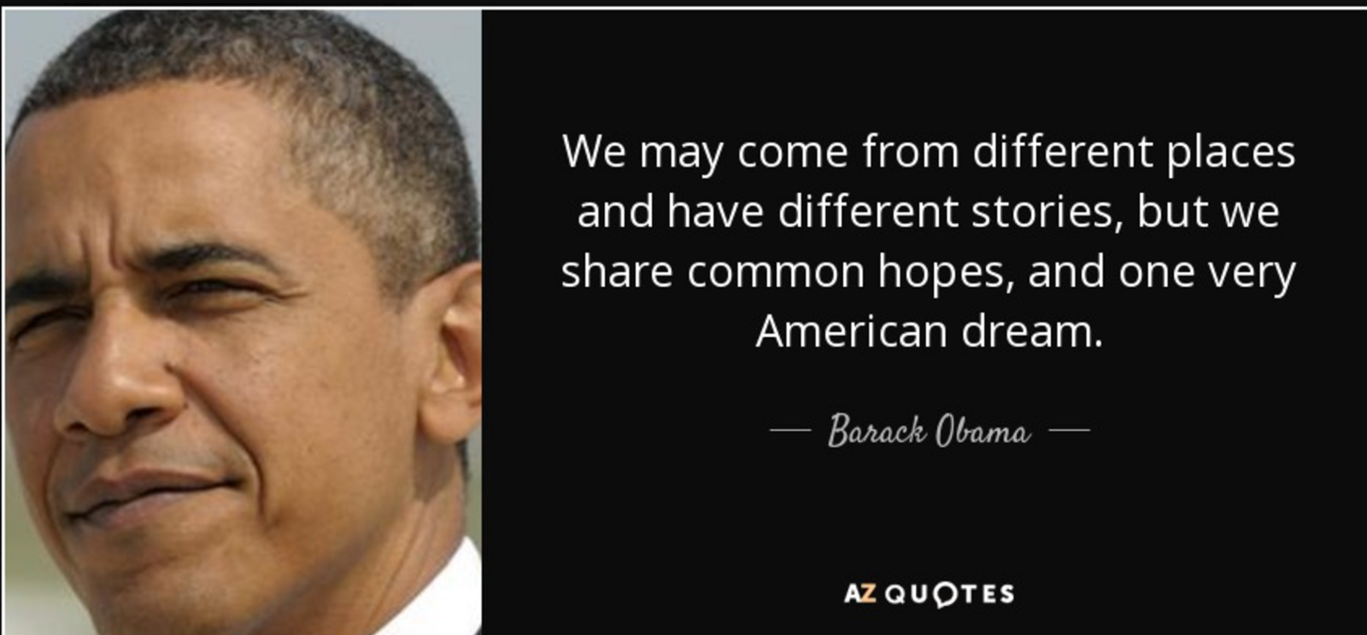

**American Dream**

by [Sean Bryant](https://www.investopedia.com/contributors/53735/), January 26, 2016

0

0131

“The idea of the American Dream has… roots (that) can be found in the Declaration of Independence, which states: “We hold these truths to be self-evident, that all men are created equal, that they are endowed by their Creator with certain unalienable Rights, that among these are Life, Liberty and the pursuit of Happiness.” In a society based on these principles, an individual can live life to its fullest as he or she defines it. America also grew mostly as a nation of immigrants who created a nation where becoming an American – and passing that citizenship to your children – didn't require being the child of an American. “

“The American Dream is the belief that anyone, regardless of where they were born or what class they were born into, can attain their own version of success in a society where upward mobility is possible for everyone. The American Dream is achieved through sacrifice, risk-taking and hard work, not by chance.”

**American Dream** 17:35 – 18:05 Q4a Manera/Kasikcier **Kasikcier**

**negative side**

# Bildergebnis fÃ¼r The American Dream Cartoon

# [The American Dream may be dead](https://nypost.com/2018/08/22/the-american-dream-may-be-dead/)

by Maria LaMagna, August 22, 2018

The “American Dream” is starting to look a lot different. Gone are the days when Americans aspired to own a house with a white picket fence. Some 82 percent of Americans now say their “American Dream” is simply financial security for themselves and their family. …

33 percent of those surveyed said they think that dream is disappearing. Why? They have too much debt. “Americans believe financial security is at the core of the American Dream, but it is alarming that so many think it is beyond their reach,” said Mike Fanning, head of MassMutual US.

Some 64 percent of those surveyed said they have a mortgage, 56 percent said they had credit-card debt and 26 percent said they have student-loan debt. Many surveyed said they don’t feel financially secure. More than a quarter said they wish they had better control of their finances.

“There is a lot of hopelessness and a lot of concern, simply because the Great Recession isn’t that far in the rearview mirror,” he said. Podnos said more people should probably redefine what the “dream” means for them,

**Immigration** 18:10 – 18:40 Q4 a Dönmez/Borozdin **Borozdin**

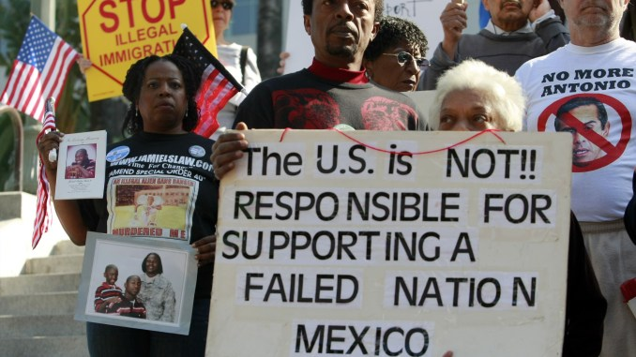

**Immigration as a problem**

**The Real Problem with Immigration... and the Real Solution**

by Kirk Johnson and Tim Kane, March 1, 2006 website of Heritage foundation

America's exceptional status as a "nation of immigrants" is being challenged by globalization, which is making both migration and terrorism much easier.

In 2005, immigration policy received far more genuine attention on Capitol Hill, and Members of Congress from both sides. Their various efforts have focused on a wide variety of changes in current policy, including improving border security, strengthening employer verification of employment, establishing a new temporary guest worker program, and offering some level of amnesty to illegal immigrants currently living in the United States.

The Real Problem: Illegal immigration into the United States is massive in scale. More than 10 million undocumented aliens currently reside in the U.S.. On one hand, the presence of so many aliens is a powerful testament to the attractiveness of America. On the other hand, it is a sign of how dangerously open our borders are.

Typical illegal aliens come to America primarily for better jobs and in the process add value to the U.S. economy. However, they also take away value by weakening the legal and national security environment. When three out of every 100 people in America are undocumented, there is a profound security problem. Even though they pose no direct security threat, the presence of millions of undocumented migrants distorts the law, distracts resources, and effectively creates a cover for terrorists and criminals.

In other words, the real problem presented by illegal immigration is security, not the supposed threat to the economy. Indeed, efforts to curtail the economic influx of migrants actually worsen the security dilemma by driving many migrant workers underground, thereby encouraging the culture of illegality.

**Immigration** 18:10 – 18:40 Q4 a Dönmez/Borozdin **Dönmez**

N**o immigration crisis!**

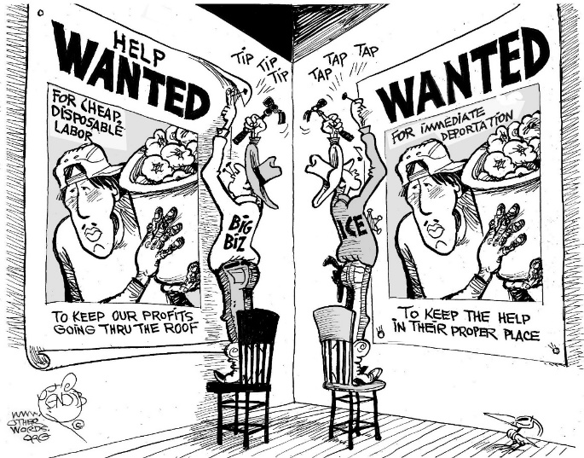

**There’s no immigration crisis, and these charts prove it**

by [**Christopher Ingraham**](https://www.washingtonpost.com/people/christopher-ingraham/) in Washington Post, June 21, 2018

The humanitarian crisis [involving immigrant children](https://www.washingtonpost.com/news/the-fix/wp/2018/06/20/trump-and-kirstjen-nielsens-embarrassing-surrender-on-separating-families/?utm_term=.e5ede30994e2) at the U.S.-Mexico border has, among other things, laid bare a number of falsehoods driving much of the Trump administration's immigration agenda.

The administration has said that the country is in danger of being “[overwhelmed](https://www.justice.gov/opa/speech/attorney-general-sessions-delivers-remarks-discussing-immigration-enforcement-actions)” by “[massive increases in illegal crossings](https://www.justice.gov/opa/speech/attorney-general-sessions-delivers-remarks-discussing-immigration-enforcement-actions)” that will bring “[horrible crime](https://twitter.com/realDonaldTrump/status/1009431025817092097),” “[unbelievably great taxpayer expense](https://twitter.com/realDonaldTrump/status/1009134789838843905)” and [the loss of American jobs](https://www.washingtonpost.com/news/post-politics/wp/2014/03/06/trump-warns-gop-on-immigration-theyre-taking-your-jobs/?utm_term=.a0446c27bc17). None of those claims are true

**Myth No. 1: Undocumented immigrants are flooding into the United States**

In fiscal 2017, apprehensions of immigrants entering illegally at the Southwest border [hit their lowest level in 46 years](https://www.washingtonpost.com/news/wonk/wp/2018/06/18/sessions-says-family-separation-is-necessary-to-keep-the-country-from-being-overwhelmed-federal-immigration-data-says-otherwise/?utm_term=.ef5b985734c0).

**Myth No. 2: Undocumented immigrants bring crime**

The [reality is just the opposite](https://www.washingtonpost.com/news/wonk/wp/2018/06/19/two-charts-demolish-the-notion-that-immigrants-here-illegally-commit-more-crime/?utm_term=.35b77d8cafdd): A large body of social-science literature has demonstrated that immigrants, legal or otherwise, commit crime at lower rates than native-born Americans.

The Cato study found evidence that undocumented immigrants are more likely to commit certain types of crime, including “gambling, kidnapping, smuggling, and vagrancy,” than native-born Americans. But those crimes accounted for less than 0.002 percent of all crimes committed in Texas during the study period.

**Myth No. 3: Immigrants take our jobs and lower our wages**

The best information comes from [a massive summary of the literature](https://www.washingtonpost.com/news/wonk/wp/2015/10/01/these-common-beliefs-about-immigrants-are-all-wrong/?utm_term=.9767eddae940) published by the [National Academies of Sciences, Engineering and Medicine in 2017](https://www.nap.edu/catalog/23550/the-economic-and-fiscal-consequences-of-immigration). “Most studies find little effect of immigration on the employment of natives,” that report concluded. In other words, no, immigrants are not taking your jobs. There is no correlation between unemployment and immigration rates in the world's wealthy nations.

**Guns** 18:45 – 19:15 Q4a Hassert/Heerwagen **Hassert**

**Guns protect youn in a dangerous world**



# What Critics Don't Understand About Gun Culture

I carry a weapon—and it’s tied me closer to my communityby [DAVID FRENCH](https://www.theatlantic.com/author/david-french/), FEB 27, 2018 in The Atlantic

My wife …was outside our house, playing with our kids on our trampoline, when a car drove slowly down our rural Tennessee street. As it reached our house, it pulled partially in the driveway, and stopped. A man got out and walked up to my wife and kids. Strangely enough, at his hip was an empty gun holster. She’d never seen him before. She had no idea who he was. He demanded to see me. I wasn’t there. I was at my office, a 50-minute drive from my house. My wife didn’t have her phone with her. She didn’t have one of our guns with her outside. She was alone with our three children. Even if she had her phone, the police were minutes away. My wife cleverly defused the confrontation before it escalated. That wasn’t the first disturbing incident in our lives, [nor would it be the last](https://www.nationalreview.com/2016/10/donald-trump-alt-right-internet-abuse-never-trump-movement/). My wife is a sex-abuse survivor and was almost choked to death in college by a furious boyfriend. In just the last five years, we’ve faced multiple threats—so much so that neighbors have expressed concern for our safety, and theirs. They didn’t want an angry person to show up at their house by mistake. We’ve learned the same lesson that so many others have learned. There are evil men in this world, and sometimes they wish you harm.

And it strikes me that many millions of Americans don’t truly understand how “gun culture” is built. It starts with the consciousness of a threat. With the consciousness of a threat comes the awareness of a vulnerability. The police can only protect the people you love in the most limited of circumstances. So you take a big step. You walk into a gun store. This is where you begin your encounter with American gun culture. The first thing you’ll notice is that the person behind that counter is ready to listen. They want to hear your experience. They’ll share their own. They’ll point you immediately to a potential solution. Always they’re ready to teach. Your first brush with this new world is positive. Sometimes you buy the gun and walk straight to the gun range. But something else happens to you, something that’s deeper than the fun of shooting a paper target. Your thought-process starts to change. Yes, if someone tried to break into your house, you know that you’d call 911 and pray for the police to come quickly, but you also start to think of exactly what else you’d do. If you heard that “bump” in the night, how would you protect yourself until the police arrived?  You’re surprised at how much safer you feel with the gun in the house.

**Guns** 18:45 – 19:15 Q4a Hassert/Heerwagen **Heerwagen**

**Gun control is necessary**



**Gun control really works — here's the science to prove it**

by [Kevin Loria](https://www.businessinsider.de/autoren/kevin-loria), 27.08.2018, in Businessinsider

**There are more than 38,000 gun deaths in the US every year, and approximately 85,000 non-fatal injuries.** There are close to as many guns in the US as there are people. The number of gun deaths in the US is incredibly high. Most of these deaths are not from mass shootings, but from firearm suicides and murders. According to the [American Public Health Association](https://www.apha.org/topics-and-issues/gun-violence), guns kill more than 38,000 people per year and cause approximately 85,000 non-fatal injuries.

**I**t's worth taking a look at the evidence we have on the effects of gun regulations. We do have evidence on effective policies that could have helped prevent some incidents.

Scientists have sought to [evaluate the effects of gun-control legislation](https://www.businessinsider.com/sandy-hook-shooting-gun-purchases-accidental-deaths-2017-12) in the US and in other places around the world. Here's what the data shows. A spike in gun purchases after the 2012 shooting at Sandy Hook Elementary School led to an increase in accidental gun deaths, especially among kids. Research has found that when people are around more guns, they're more likely to end up [dying from accidental shootings](http://www.businessinsider.com/sandy-hook-shooting-gun-purchases-accidental-deaths-2017-12). After a 20-year-old man killed 20 children and six adults at Sandy Hook Elementary School in Newtown, Connecticut in December 2012, there were calls for legislation that would limit some people's access to firearms. That push resulted in what's now become a predictable phenomenon after shootings: people bought lots of guns.

With more guns around in the months after the school shooting, the rate of accidental deaths related to firearms rose sharply, especially among children, [according to a recent study](http://science.sciencemag.org/cgi/doi/10.1126/science.aan8179) published in the journal Science. The researchers' calculations showed that 40 adults and 20 children died as a result of those additional gun purchases.

**Immigration** 19:20 – 19:50 Q4 b Yilmaz/Zemrauoi **Yilmaz**

**Immigration as a problem** 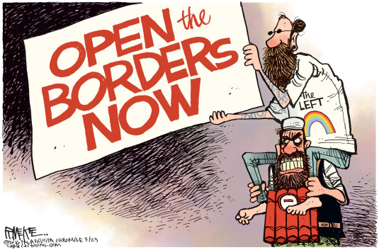

**Immigration as a problem**

**The Real Problem with Immigration... and the Real Solution**

by Kirk Johnson and Tim Kane, March 1, 2006 website of Heritage foundation

America's exceptional status as a "nation of immigrants" is being challenged by globalization, which is making both migration and terrorism much easier.

In 2005, immigration policy received far more genuine attention on Capitol Hill, and Members of Congress from both sides. Their various efforts have focused on a wide variety of changes in current policy, including improving border security, strengthening employer verification of employment, establishing a new temporary guest worker program, and offering some level of amnesty to illegal immigrants currently living in the United States.

The Real Problem: Illegal immigration into the United States is massive in scale. More than 10 million undocumented aliens currently reside in the U.S.. On one hand, the presence of so many aliens is a powerful testament to the attractiveness of America. On the other hand, it is a sign of how dangerously open our borders are.

Typical illegal aliens come to America primarily for better jobs and in the process add value to the U.S. economy. However, they also take away value by weakening the legal and national security environment. When three out of every 100 people in America are undocumented, there is a profound security problem. Even though they pose no direct security threat, the presence of millions of undocumented migrants distorts the law, distracts resources, and effectively creates a cover for terrorists and criminals.

In other words, the real problem presented by illegal immigration is security, not the supposed threat to the economy. Indeed, efforts to curtail the economic influx of migrants actually worsen the security dilemma by driving many migrant workers underground, thereby encouraging the culture of illegality.

**Immigration** 19:20 – 19:50 Q4 b Yilmaz/Zemrauoi **Zemraoui**

**Immigration? No problem**

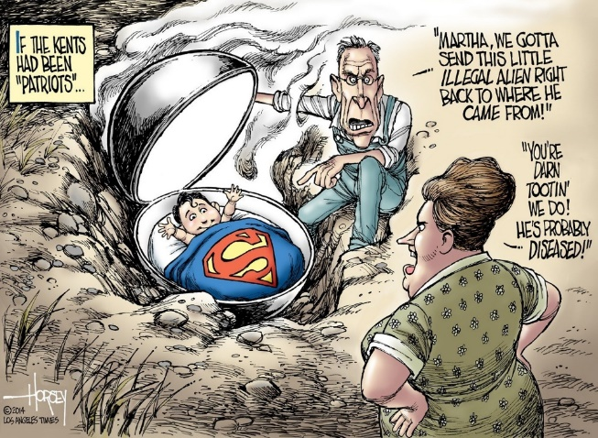

**There’s no immigration crisis**

by [**Christopher Ingraham**](https://www.washingtonpost.com/people/christopher-ingraham/) in Washington Post, June 21, 2018

The humanitarian crisis [involving immigrant children](https://www.washingtonpost.com/news/the-fix/wp/2018/06/20/trump-and-kirstjen-nielsens-embarrassing-surrender-on-separating-families/?utm_term=.e5ede30994e2) at the U.S.-Mexico border has, among other things, laid bare a number of falsehoods driving much of the Trump administration's immigration agenda.

The administration has said that the country is in danger of being “[overwhelmed](https://www.justice.gov/opa/speech/attorney-general-sessions-delivers-remarks-discussing-immigration-enforcement-actions)” by “[massive increases in illegal crossings](https://www.justice.gov/opa/speech/attorney-general-sessions-delivers-remarks-discussing-immigration-enforcement-actions)” that will bring “[horrible crime](https://twitter.com/realDonaldTrump/status/1009431025817092097),” “[unbelievably great taxpayer expense](https://twitter.com/realDonaldTrump/status/1009134789838843905)” and [the loss of American jobs](https://www.washingtonpost.com/news/post-politics/wp/2014/03/06/trump-warns-gop-on-immigration-theyre-taking-your-jobs/?utm_term=.a0446c27bc17). None of those claims are true

**Myth No. 1: Undocumented immigrants are flooding into the United States**

In fiscal 2017, apprehensions of immigrants entering illegally at the Southwest border [hit their lowest level in 46 years](https://www.washingtonpost.com/news/wonk/wp/2018/06/18/sessions-says-family-separation-is-necessary-to-keep-the-country-from-being-overwhelmed-federal-immigration-data-says-otherwise/?utm_term=.ef5b985734c0).

**Myth No. 2: Undocumented immigrants bring crime**

The [reality is just the opposite](https://www.washingtonpost.com/news/wonk/wp/2018/06/19/two-charts-demolish-the-notion-that-immigrants-here-illegally-commit-more-crime/?utm_term=.35b77d8cafdd): A large body of social-science literature has demonstrated that immigrants, legal or otherwise, commit crime at lower rates than native-born Americans.

The Cato study found evidence that undocumented immigrants are more likely to commit certain types of crime, including “gambling, kidnapping, smuggling, and vagrancy,” than native-born Americans. But those crimes accounted for less than 0.002 percent of all crimes committed in Texas during the study period.

**Myth No. 3: Immigrants take our jobs and lower our wages**

The best information comes from [a massive summary of the literature](https://www.washingtonpost.com/news/wonk/wp/2015/10/01/these-common-beliefs-about-immigrants-are-all-wrong/?utm_term=.9767eddae940) published by the [National Academies of Sciences, Engineering and Medicine in 2017](https://www.nap.edu/catalog/23550/the-economic-and-fiscal-consequences-of-immigration). “Most studies find little effect of immigration on the employment of natives,” that report concluded. In other words, no, immigrants are not taking your jobs. There is no correlation between unemployment and immigration rates in the world's wealthy nations.

**Guns** 19:55 – 20:25 Q4b Kocak/Lenz **Kocak**

**Guns protect youn in a dangerous world**



# What Critics Don't Understand About Gun Culture

I carry a weapon—and it’s tied me closer to my communityby [DAVID FRENCH](https://www.theatlantic.com/author/david-french/), FEB 27, 2018 in The Atlantic

My wife …was outside our house, playing with our kids on our trampoline, when a car drove slowly down our rural Tennessee street. As it reached our house, it pulled partially in the driveway, and stopped. A man got out and walked up to my wife and kids. Strangely enough, at his hip was an empty gun holster. She’d never seen him before. She had no idea who he was. He demanded to see me. I wasn’t there. I was at my office, a 50-minute drive from my house. My wife didn’t have her phone with her. She didn’t have one of our guns with her outside. She was alone with our three children. Even if she had her phone, the police were minutes away. My wife cleverly defused the confrontation before it escalated. That wasn’t the first disturbing incident in our lives, [nor would it be the last](https://www.nationalreview.com/2016/10/donald-trump-alt-right-internet-abuse-never-trump-movement/). My wife is a sex-abuse survivor and was almost choked to death in college by a furious boyfriend. In just the last five years, we’ve faced multiple threats—so much so that neighbors have expressed concern for our safety, and theirs. They didn’t want an angry person to show up at their house by mistake. We’ve learned the same lesson that so many others have learned. There are evil men in this world, and sometimes they wish you harm.

And it strikes me that many millions of Americans don’t truly understand how “gun culture” is built. It starts with the consciousness of a threat. With the consciousness of a threat comes the awareness of a vulnerability. The police can only protect the people you love in the most limited of circumstances. So you take a big step. You walk into a gun store. This is where you begin your encounter with American gun culture. The first thing you’ll notice is that the person behind that counter is ready to listen. They want to hear your experience. They’ll share their own. They’ll point you immediately to a potential solution. Always they’re ready to teach. Your first brush with this new world is positive. Sometimes you buy the gun and walk straight to the gun range. But something else happens to you, something that’s deeper than the fun of shooting a paper target. Your thought-process starts to change. Yes, if someone tried to break into your house, you know that you’d call 911 and pray for the police to come quickly, but you also start to think of exactly what else you’d do. If you heard that “bump” in the night, how would you protect yourself until the police arrived?  You’re surprised at how much safer you feel with the gun in the house.

**Guns** 19:55 – 20:25 Q4b Kocak/Lenz **Lenz**

**Gun control is necessary**

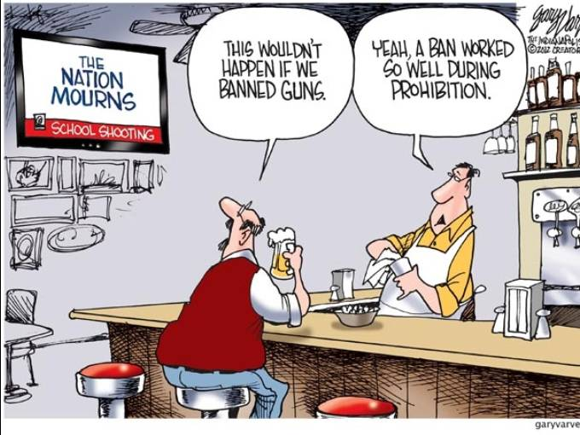

**Gun control really works — here's the science to prove it**

by [Kevin Loria](https://www.businessinsider.de/autoren/kevin-loria), 27.08.2018, in Businessinsider

**There are more than 38,000 gun deaths in the US every year, and approximately 85,000 non-fatal injuries.** There are close to as many guns in the US as there are people. The number of gun deaths in the US is incredibly high. Most of these deaths are not from mass shootings, but from firearm suicides and murders. According to the [American Public Health Association](https://www.apha.org/topics-and-issues/gun-violence), guns kill more than 38,000 people per year and cause approximately 85,000 non-fatal injuries.

**I**t's worth taking a look at the evidence we have on the effects of gun regulations. We do have evidence on effective policies that could have helped prevent some incidents.

Scientists have sought to [evaluate the effects of gun-control legislation](https://www.businessinsider.com/sandy-hook-shooting-gun-purchases-accidental-deaths-2017-12) in the US and in other places around the world. Here's what the data shows. A spike in gun purchases after the 2012 shooting at Sandy Hook Elementary School led to an increase in accidental gun deaths, especially among kids. Research has found that when people are around more guns, they're more likely to end up [dying from accidental shootings](http://www.businessinsider.com/sandy-hook-shooting-gun-purchases-accidental-deaths-2017-12). After a 20-year-old man killed 20 children and six adults at Sandy Hook Elementary School in Newtown, Connecticut in December 2012, there were calls for legislation that would limit some people's access to firearms. That push resulted in what's now become a predictable phenomenon after shootings: people bought lots of guns.

With more guns around in the months after the school shooting, the rate of accidental deaths related to firearms rose sharply, especially among children, [according to a recent study](http://science.sciencemag.org/cgi/doi/10.1126/science.aan8179) published in the journal Science. The researchers' calculations showed that 40 adults and 20 children died as a result of those additional gun purchases.

10-minütige Vorbereitungsphase 2 Schüler/Aufsicht Dictionary En/Deu, in der sich die Prüflinge mit den Materialien und den Aufgaben vertraut machen

2 Minuten Aufwärmphase mit Alltagskommunikation

4 Minuten monologische Prüfungsteil je Kanidat

4 Minuten dialogische Prüfungsteil, wobei dieser zeitliche Umfang auch in geringem Maße überschritten werden kann

ca. 24 min plus Notengebung

Im Anschluss an die Prüfungsphase: Notengebung

Leistungsbewertung

Leistungsbewertung

Der Leistungsbewertung liegt der beigefügte Bewertungsbogen zu Grunde, der sich an den Anforderungen im Bereich B2/C1 des Gemeinsamen europäischen Referenzrahmens orientiert. Für alle Aufgabenteile gilt:

Die Prüflinge können ■ sich zu einem breiten Themenspektrum klar und detailliert ausdrücken (Globalskala Sprechen), ■ sich spontan und fließend ausdrücken (an Gesprächen teilnehmen) und ■ eine klare und detaillierte Darstellung zu Themen aus ihrem Interessengebiet geben (zusammenhängendes Sprechen). 9 in den Leistungskursen der modernen Fremdsprachen Für die Prüfungsphase 1 (monologisches Sprechen) gilt: Die Prüflinge können ■ sich auf der Basis einer Unterrichtssequenz aus dem gegebenen Halbjahr (Q3/Q4) impulsgesteuert äußern, ■ Vor- und Nachteile verschiedener Optionen angeben, ■ ihre Meinungen äußern, ■ auf die Meinung anderer Bezug nehmen und eingehen sowie ■ einen Standpunkt erläutern. Für die Prüfungsphase 2 (dialogisches Sprechen) gilt: Die Prüflinge können ■ sich in vertrauten Situationen aktiv an einer Diskussion beteiligen, ■ einen Standpunkt zu einer aktuellen Frage erläutern, ■ ihre Ansichten begründen und verteidigen, ■ ihre Äußerungen angemessen einleiten, ■ ihre Beiträge mit denen anderer verknüpfen und damit zum Fortgang des Gesprächs beitragen.

Der Bewertungsbogen bezieht Inhalt, Sprachrichtigkeit und Ausdrucks- sowie Interaktionsvermögen in die Bewertung ein. Monologischer und dialogischer Teil werden getrennt bewertet. Beide Prüfungsteile gehen gleichgewichtig in die Wertung ein. Ergänzt werden sie durch eine Bewertung der Sprachrichtigkeit (in beiden Teilen) sowie durch eine Einschätzung des Gesamteindrucks. Die Umrechnung der insgesamt maximal 100 Punkte in Notenpunkte folgt der Umrechnungstabelle der OAVO, Anlage 9. Beide Lehrkräfte evaluieren die Leistungen der Prüflinge mit Hilfe des Bewertungsbogens. Auf der Basis des Bewertungsbogens und des während der Prüfung gewonnenen Eindrucks einigen sich die Lehrkräfte auf eine Note (gemäß OAVO §9 Abs.1). Im Falle der Nichteinigung wird in der Regel die Note gemittelt. Bei völlig unterschiedlichen Einschätzungen der Prüfungsleistungen wird eine Entscheidung gemeinsam mit der Schulleitung auf der Grundlage der Einschätzungen auf den Bewertungsbögen getroffen.