**topic: Utopia/Distopia**

**negative side**

## **source:** [**Ariel Arancibia @arielarancibia_designer**](https://www.domestika.org/en/arielarancibia_designer) **nach dem Film „I am legend“** aus dem Jahr 2007 mit Will Smith

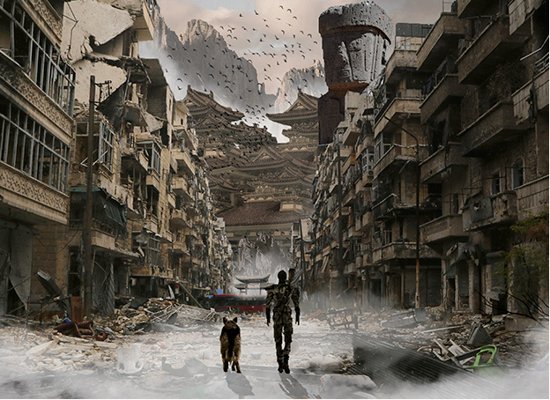

**source: *Aldous Huxley, Brave New World***

A classic dystopian, science-fiction novel by English author Aldous Huxley, *Brave New World* has become a worldwide literary classic and a mainstay in high school English curriculums since its 1932 release.

Its insidious and disturbing story introduces us to the futuristic World State, in which citizens are genetically modified, molded into a strict social hierarchy, brainwashed into loving their own servitude and forced into a doctored happiness that comes in the form of a government-issued drug. Led by a dictatorial “Controller” named Mustapha Mond, the World State is an unsettling, sinister place endowed with warped visions of an ideal society meant to alienate and disgust readers who value truth, love, beauty and freedom.

*Brave New World* is stuffed with classic quotes and phrases that rear their heads in essays, papers and other literary works. Here are a few of our favorites.

**“But I don’t want comfort. I want God, I want poetry, I want real danger, I want freedom, I want goodness. I want sin.”**

John the Savage incites chaos when he throws out the soma, a government-sponsored drug, at a hospital. When he’s brought before the great Controller Mustapha Mond to answer for his crime, John gets sick of Mond’s talks of being comfortable and responds with this great rallying cry for adventure and nonconformity.

**topic: Utopia**

**positive side**

**source: Future City HD 20 by Giimann**

# Bildergebnis für Utopia

# Source: Eduardo Hughes Galeano war ein uruguayischer Journalist und Schriftsteller.

# 