 Arbeitsblätter SM  Source: https://www.gradesaver.com/author/sindiwe-magona  Tasks:  - Find out how real life incidents inspired the author to write this book. (Material1)  Write a short essay!  Source:  https://www.nytimes.com/1993/08/27/world/how-american-sister-died-in-a-township.html  - The student members of a militant black nationalist group, the Pan-Africanist Congress, who killed the young woman have the slogan "One settler, one bullet."  Use Material 2 and try to find out how they justify even sporadic massacres of whites at church, of children at play and whites at home.  Write a short essay. |  | Mother to Mother  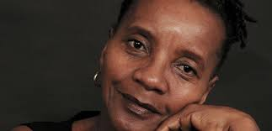  Biography of the author  Sindiwe Magona  Sindiwe Magona is a South African author. During the 1990s, She grew up in Bouvlei, and spent her early career working as a domestic in nearby Cape Town. She later graduated from the University of South Africa and attended Columbia University for graduate school. She currently works as the writer-in-residence at the University of the Western Cape.  In the 1990s, Magona lived in the township of Guguletu. In 1993, American student and anti-Apartheid activist Amy Biehl was murdered on the road near Guguletu; Magona lived down the road from one of her killers. This experience inspired her to write Mother to Mother, a fictionalized account of the events surrounding Biehl's death written from the perspective of one of the killers' mothers, named Mandisa—a woman who, like Magona herself, worked as a domestic in Cape Town.  In her career, Magona has written nine books, including two autobiographical works, collections of short stories, children's books, and an anthology of poetry. Notably, she was the first author to ever publish a series of children's books in the Xhosa language.  Magona's work is informed by her experience growing up in apartheid in South Africa. She has brought her first-hand experience with impoverishment and resistance to subjugation with her as she moved into the United States.  How American 'Sister' Died in a Township  By Bill Keller  - Aug. 27, 1993  In New York Times  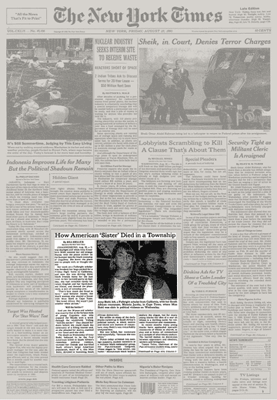  It was daylight still when Amy Elizabeth Biehl steered her old orange Mazda with the peace sticker on the bumper into the black township of Guguletu. She knew the place and its people well, or thought she did.  Her work as a Fulbright scholar was finished, her bags packed for a Friday flight home to California, and now she was driving three black friends home for the last time. At her farewell party on Sunday, she had switched easily between English and her hard-studied Xhosa, and danced the phan tsula, a sort of township jive.  "That's how much she fitted in here," said Melanie Jacobs, the black woman who shared a house with Miss Biehl in Cape Town. "She loved Africa. She wasn't just another white person." 'Kill the Settler!'  And yet the 26-year-old scholar was exactly that to the furious mob of young Guguletu men who stopped the Mazda with a brick through the windshield. Yelling "Kill the settler!" they chased her down before she could reach the sanctuary of a filling station and, as she pleaded for mercy, stabbed at her head until she died.  The death on Wednesday of Amy Biehl, believed to be the first American killed in South Africa's relentless political violence, stunned her friends and horrified South Africa's large American population, much of it, like Miss Biehl, devoted to hastening South African democracy.  But unlike so many of the daily deaths racked up in South Africa's political tumult, in which motive and blame are matters of conjecture, Amy Biehl's was remarkably unmysterious.  She was killed, her roommate said mournfully, "because she was white."  Police today arrested two teen-age suspects, student members of a militant black nationalist group, the Pan-Africanist Congress, whose slogan is "One settler, one bullet." Mainstream black leaders deplore the slogan, but for many young blacks the idea of a war on whites is a thrilling outlet for volcanic frustration and resentment.  In recent months many young blacks have applauded sporadic massacres of whites at church, at play and at home, all rationalized as a sample of what blacks endure. The hatred makes no distinction between oppressors and idealists, settlers and foreigners.  Tsietsi Telite, chairman of the Pan-Africanist student wing, coolly accepted the killing, telling reporters today, "Given the situation on the ground, the youths and students are so angry and frustrated that when they see someone who they identify with the dispossessing classes, anything can happen, and could happen again."

